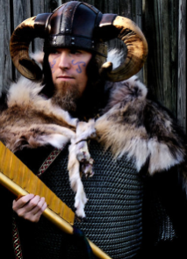
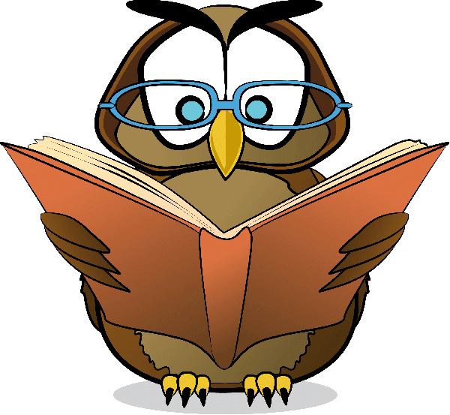
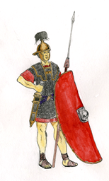
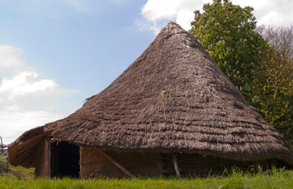
Wellbeing
The wellbeing of the children as they return to school is of the utmost importance. Experiencing 'Life in all its fullness’ (John 10:10) we will be using our amazing Wellbeing area just outside the year 4 classrooms and taking our learning outside as often as possible.

History
Our topic this term is the Iron Age and, after half term, the Romans. We will be looking at how people lived in these times including their clothing, homes and daily life. What they believed and how life changed due to significant events. We will find out what their legacy is for us today and how they left their mark on Britain. We will make our own models and art work and independently research aspects that interest us.
Watch out for an Iron Age Celt Day and Roman trip later in the term.
Geography
In geography, we will be working with maps and Atlases. We will be investigating land use and how the map of Britain changed through the period of history we are studying.
RE
In RE we will be learning about Christianity. It is of course the term when we celebrate Harvest Festival and Christmas.
French
This term we will be learning how to greet and ask questions of someone has well as count numbers and words we might use in a classroom
Forest school/outdoor learning
We aim to use the outdoors for as much of our learning as we can – adapting and reimagining lessons in the fresh air!
Science
In the first half term, we are learning about Sound including looking at pitch, vibrations and volume. Investigating amplitude and acoustics and making our own telephones. Then after half term, we will be thinking all about how we eat and digest our food. We will find out about our teeth and investigate animal food chains. There will be lots of exciting investigations to do and interesting facts to find out.
PE
In PE, on alternate Tuesdays and every Friday we will be developing our balance, core strength and coordination in our Real PE lessons along with Multi-skills, including running, throwing and jumping as well as dribbling with a football and basketball.
Year 4
Autumn Term
Our school values are Community, Resilience and Kindness
‘Carnival’
Maths
In maths this term, we will be learning about:
- place value to 10,000; including rounding numbers to 10, 100 and 1000 and negative numbers
- Roman Numerals to 100
- how to use formal calculation methods for adding, subtracting, multiplying and dividing.
- measuring length and perimeters.
To continue to develop our reasoning skills, we will be solving lots of problems and puzzles.
In Year 4 we need to know all our times tables ready for our times table assessment in the summer term. Remember to practise on TT Rockstars so you are really quick! Look out for competitions!

Art and Design
This term we will be continuing to develop our use of sketchbooks to explore ideas, improve our skills in drawing and using colour and tone. We will be exploring other media through our topic work including painting, textiles, clay and collage.
Design and Technology
We will be using natural materials to build our own roundhouses, designing and making clay pots and evaluating, tasting and designing our own Iron Age bread.
Music
This term we will be learning about pulse, rhythm and pitch, learning to sing songs in a round along with musical terms associated with this.
Computing
This term we will be learning about computing systems and networks as well as creating media by editing audio, as well as our online safety units on being kind and responsible.
English
In English our focus continues to be reading; developing our independent skills and using Accelerated Reading to keep track of our progress. We will be listening to, learning and retelling stories as well as writing our own. We will look at a range of non-fiction texts and identify the features of these to use in our writing.
We will be creating our own poetry based upon similes. We will study a range of texts starting with an African Folk Tale “Fly Eagle Fly” which is a story about achieving your potential. In addition we will be using our writing skills across the curriculum.
In spelling, we will continue to look at patterns and rules as well as exploring how prefixes and suffixes change the meaning of words.
Vocabulary is also an important focus – we will be collecting powerful words to use in our writing and trying to use the correct subject vocabulary to explain about what we are learning.

