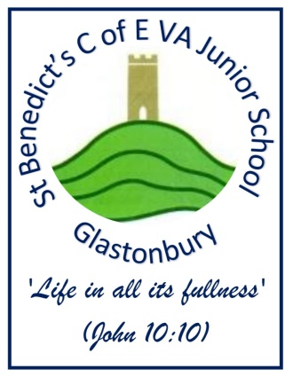
St Benedict’s C. of E. VA Junior School
Benedict Street, Glastonbury, Somerset, BA6 9EX
Tel: 01458 831811, Fax: 01458 832261
www.stbenedictscofevajuniorschoolglastonbury.co.uk
School164@stbens.school
Headteacher: Mr Piers Ranger

Dear Mums, Dads and Carers,

Our school milk scheme

Our school provides a milk scheme that is available to all of our pupils and we would like to invite you to register your child. Milk is available at a subsidised* price of 22p per child per day. Any children receiving or entitled to free school meals can receive milk free.

Each child that registers with Cool Milk will receive a 189ml portion of semi-skimmed milk every day, delivered fresh and chilled to the classroom. Their school milk will not only provide them with essential nutrients, but as it is rehydrating and energy boosting it also bridges the gap between breakfast and lunch to help children stay focused. For more information on how milk can benefit children visit www.coolmilk.com/why-milk-is-great.

How to register and pay

• Register and pay online at www.coolmilk.com

• Alternatively, fill in a registration form available from the school office – once Cool Milk has processed your form, you will receive a payment request

• You can pay Cool Milk either online, over the phone or at a local PayPoint in half-termly, termly or annual instalments

• Please pay by a Tuesday at 5pm for your child’s milk to start the following week

If you have any questions regarding school milk please visit www.coolmilk.com or contact Cool Milk directly on 0844 854 2913. More information on milk is also available from the school.

Yours sincerely

Mr P Ranger

Mr P Ranger
Head teacher

*Milk provided for over-5 children is subsidised by the Rural Payments Agency and the E.U

