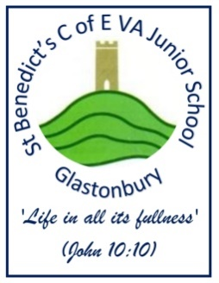
ST. BEN’S BULLETIN: 14th July 2023
Please see our PTFA Facebook Page
Contact school: school164@stbens.school
Website: stbenedictscofevajuniorschoolglastonbury.co.uk/

St. Ben’s School Christian Values: Community, Resilience and Kindness

CHAMPIONS! Rounders Team Wins League
They’ve done it! After a number of difficult
fixtures, the incredible St. Ben’s Rounders’ Team
have emerged victorious, winning the Schools’
League after an undefeated season. Their latest
triumph was a cagey 53 – 45 win Over a very
competitive Brookside B team.

A huge well done to the whole team who were
fantastic and showed great teamwork and
resilience throughout the season. Also, a HUGE
thank you to Mrs Brown, Mrs Varney and Mr
Lintell for their coaching. Finally to parents,
carers, friends and staff for their enthusiastic
support of the team this season.

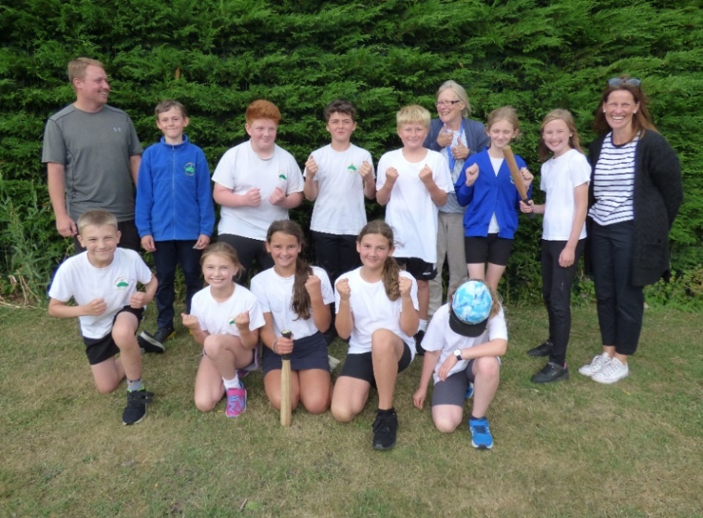

RECORD-BREAKING BENFEST! THANK YOU PTFA!
On a glorious Friday night, this year’s BenFest was a smash hit featuring amazing music and performance, tasty treats and incredible fun and games, including the fabulous Year 5 stalls. We also had a raffle, the cake auction (featuring some incredible cakes) and much, much more. A huge thank you to our awesome PTFA and to all the other helpers. We raised a record-breaking £3458.50, which will go towards revamping our play area.

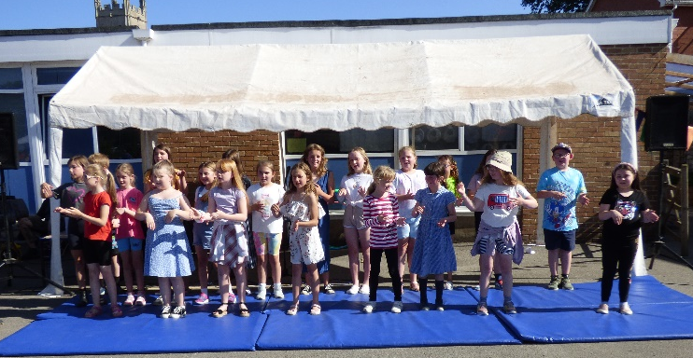
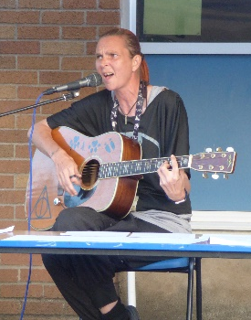
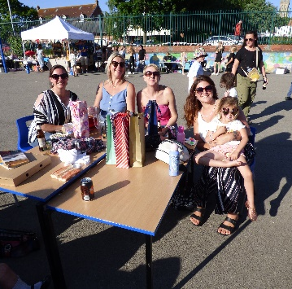
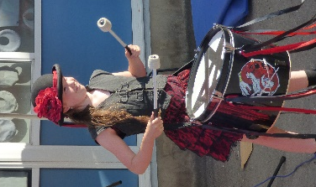

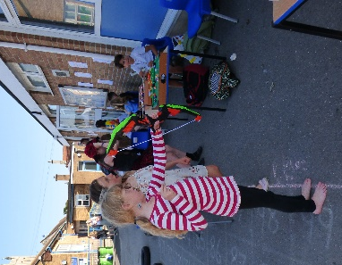
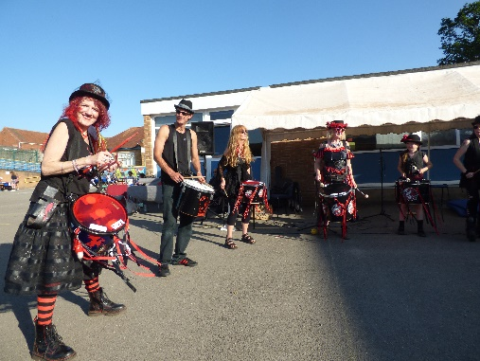
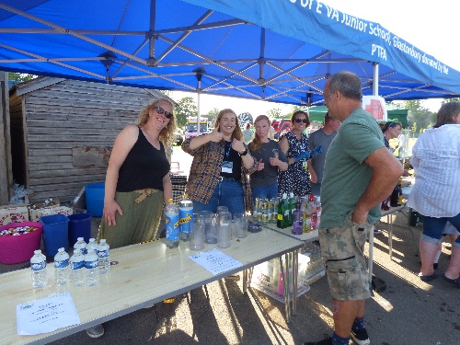

MUSIC CONCERT WOWS AUDIENCE
On Tuesday, St. Benedict’s Church played host to a special music concert organised by Mrs Coton, at which we celebrated all the music and singing happening at school this year. There were performances by pianists, violinists, guitarists, recorder players, Glee Club, the Choir and Year 4. It was a wonderful occasion which parents and carers enjoyed hugely. A huge thank you to Mrs Coton, for organising the event and to all our music teachers for their vital input this year – you help our children to express themselves! Also a special thank you to Matthew Redman, of St. John’s Choir, who accompanied the children on piano.

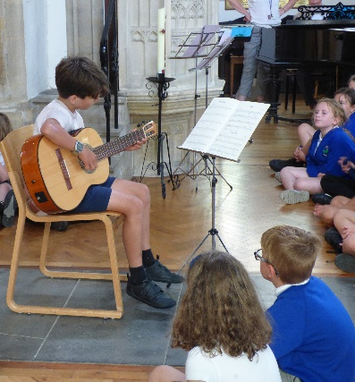
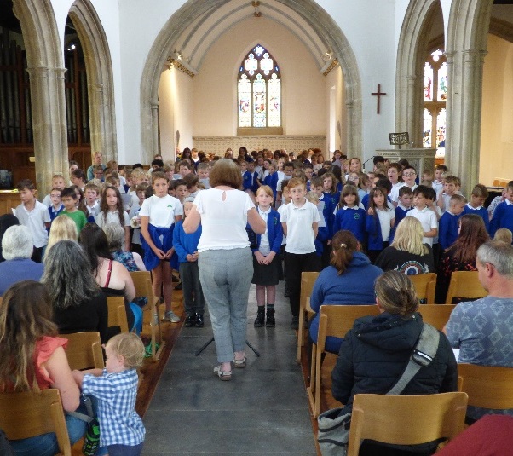
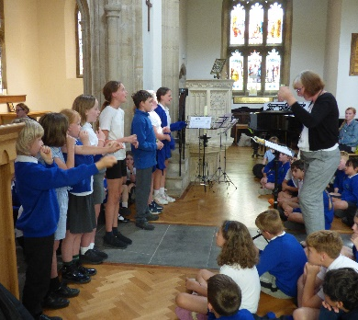
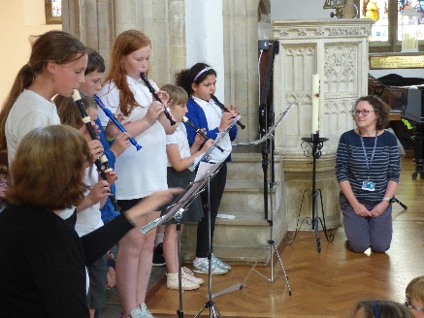

ACHIEVEMENTS and AWARDS
Class:  Cats:  Unicorns:  Cham:  Owls:  Spiders:  Tortoises:  Leopards:  Peacocks: | Headteacher’s Award |  | Teacher’s Award
 | Mark: for always supporting other children with their reading.  Nellie: amazing performance in Glee Club.  Meg H: for being kind and helpful always with a sunny smile.  Theo: for being a kind friend, always working hard.  Ethan H: for appropriate thoughtful and mature participation in RSE sessions.  Harry: for a fantastic positive attitude to his learning.  Spencer: for always being a pleasure to have in the classroom.  Cole: for working tirelessly to help tidy up after BenFest. |  | Logan B: for his fantastic swimming! Amazing Logan!  Sophia: for dedication to her music.  Letty: for always offering to help others.  Solomiia: for super golden write story, always working with a smile!  Holly: for always being fantastic – all the time!  Monika: for showing kindness to her friends.  Lilith-Anna: for a mature approach to RSE week!  Casper: for an excellent attitude towards his reading.
Book Battle Champs | This week the following % of children managed to read 5 x a week at home:  Cat - %, Unicorn - 71%, Owl - %, Chameleon - %  Tortoise –%, Spider –%, Leopard - %, Peacock - %  This week’s champs are Unicorn Class! Well done Unicorns. This half term’s winners are Owl Class and Tortoise Class who get their own mufti day next Thursday.
Reading Awards: |  | AR Target: Bobby (Y3); Jakob and Sasha (Y4)
Learning Awards | Bronze: Noah (Yr4), Kian, Viktor and Billyray (Yr5); Silver: Mori, Logan G (Yr3), Xahli and Luna (Yr4), Freddie, Ethan H, Ethan W, Stacey and Noah (Yr5). Gold: Logan B and Elijah (Yr3) and Oliver, Jamie, Sasha, Solomiia, Jacob R, Shahala and Orrin (Yr4), Zahan, Arthur, Corey, Mya, Katie, Chester and Precious (Yr5) and Toby, Aimee and Ava (Yr6)  Platinum: Raphael (Yr3), Mason B, Jake and Jasmine (Yr4), Dulcie and Sam (Yr5)
Other Awards | Beehive Award: Charlie L, Derek, Austen, Willow, Faye, Mori, Jack R and Charlie D: for completing Nurture Group. Star Awards: ELSA: Noah and Talia (Yr4) and Rhiley (Yr6)  CLASS DOJO CHAMPS: OWLS (36 points average)  ATTENDANCE CHAMPS: UNICORN (100%). Well done, everyone!

GLEE CLUB ROCK ST. BEN’S
On Wednesday afternoon, we opened the gates early for parents and friends to join us for a Glee Club performance to remember. The whole school rocked
out as Glee Club
entertained us with their
rock and roll playlist.
Amazing work work Glee
Club and thanks (again) to
the incomparable Ms
Grenter.

SURPRISE THEATRE PERFORMANCE
Pupils at St. Ben’s were treated to a surprise performance of The Secret Garden on Wednesday this week. When a local school cancelled their booking, MandM theatre agreed to come in to perform to free of charge. The performance went down a storm, with children raving about the set and production, as well as the performance itself. We were all very grateful for this act of kindness; it was an unexpected treat!

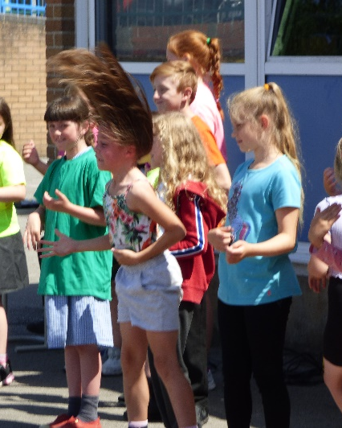

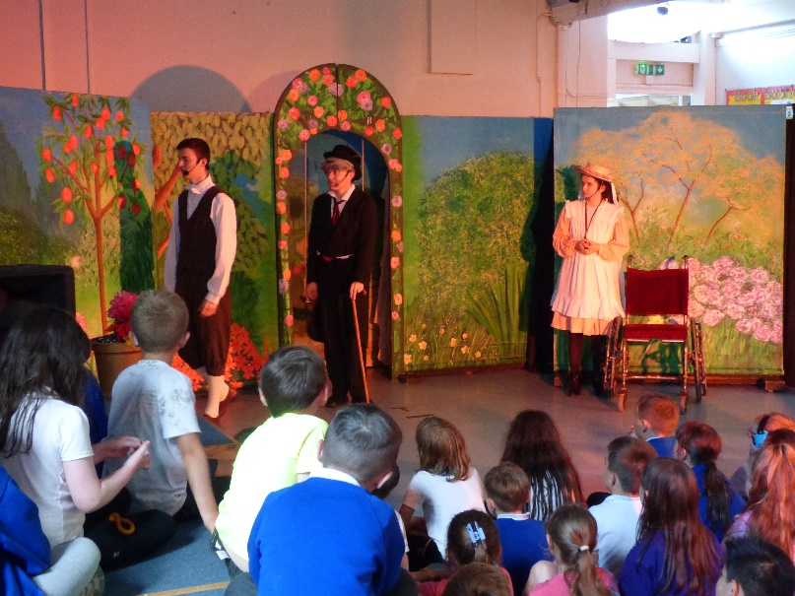

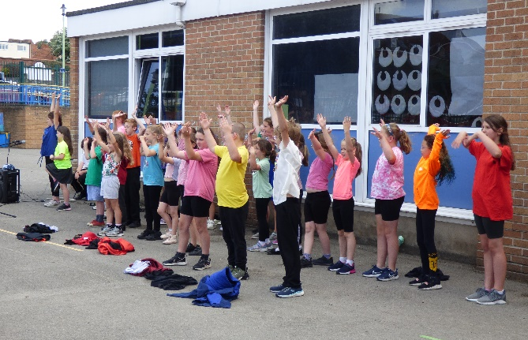

MINI-POLICE LITTER PICK AND ASSEMBLY
Our Year 5 Mini-Police cadets have been busy this week! First up,
they were on hand to help Katie Moyse and the team along with
Mr Ranger with a litter pick at Tor Leisure on Wednesday lunchtime.
They discovered a worrying amount of rubbish at the playing grounds
and safely disposed of it to make the place a safer and more pleasant
environment for our children (and animals) to play.

Then, they presented a whole-school assembly on Thursday, reflecting on their year as Mini-Police, including such adventures as Dementia training, a visit to the Mounted Horse Section, learning the phonetic alphabet, and lots more. Their aim was to inspire next year’s Year 5 to apply for the role in September. Well done, Mini-Police and a huge thank you to Katie, Amy, Nick, Mel and the team for delivering another brilliant programme this year!

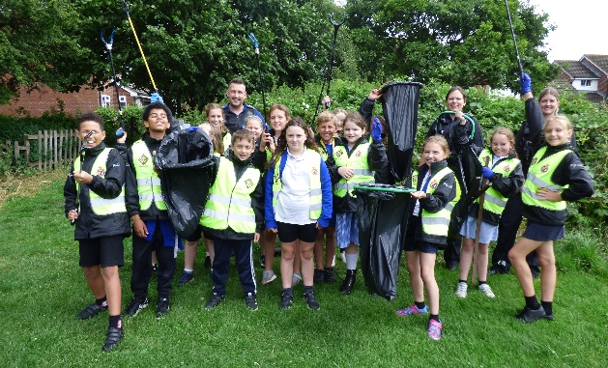

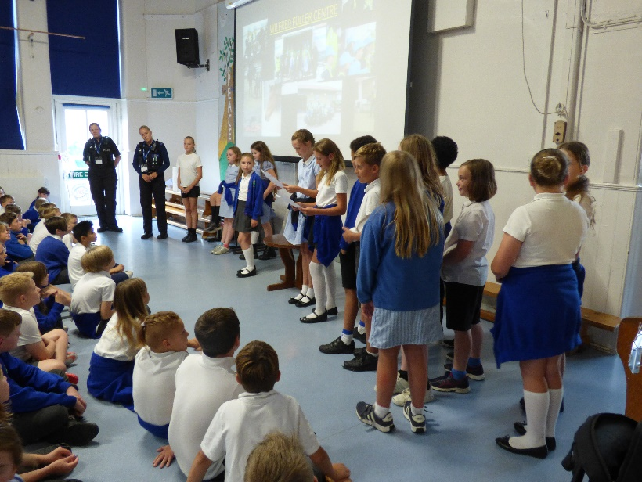
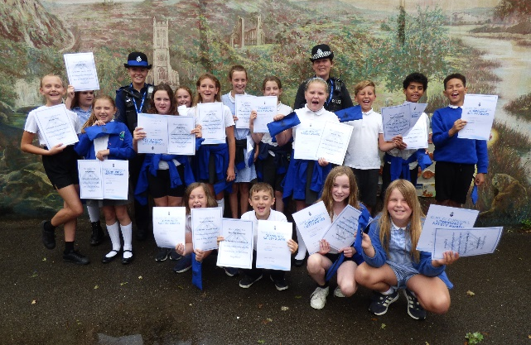
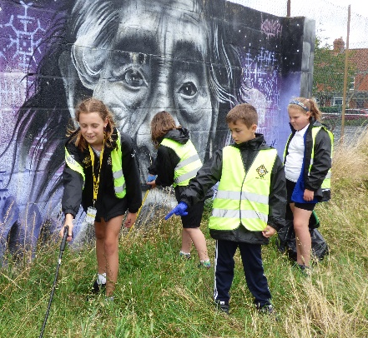
YEAR 4 VIKING DAY
On Thursday this week, Year 4 enjoyed a Viking Day with a range of activities to give them a flavor of what life was like for Vikings. Sessions included creating a stew, sewing Viking money pouches which were embroidered with rune initials. They also made pop-up boats and ended the day by tasting their delicious stew!

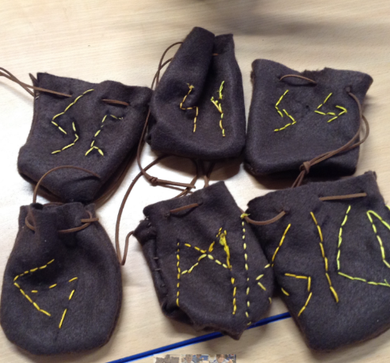
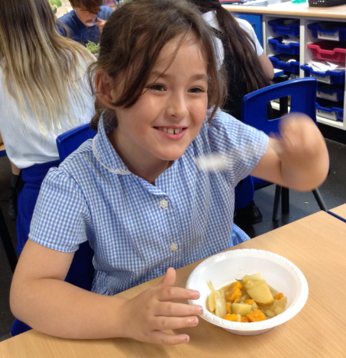
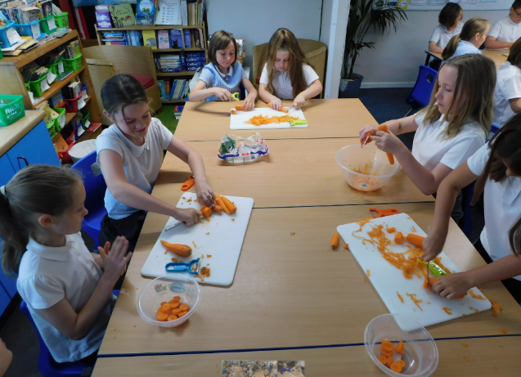

LIBRARY SUMMER READING CHALLENGE
On Thursday this week, Selena Gunn from the
Library visited us to introduce this summer’s
Reading Challenge, which has already begun.
This year the theme is Sports-related and, as ever,
children are set the target of reading 6 books over
the summer holidays (the deadline is 9th September)
It’s free to enter – simply go to Glastonbury Library
to sign up. There are stickers to be had and also a
medal for those who complete the challenge! Go on,
give it a go, and let’s see if we can break our school record of 45 pupils taking part!



What are you up to?
Our weekly update on our pupils’ adventures out of school. This week, we feature two Upper School pupils who have shone. First, it’s Lily in Year 6 who won a Silver medal for Gymnastics at the Edge competition in June. Also to Sol (and his wonderful horse, Leroy) who has earned a ‘well done’ certificate from the riding stables in Burcott. Well done, both of you!

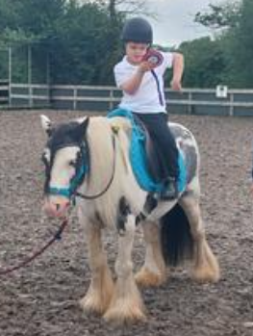
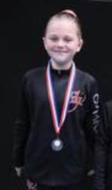

Left: Lily wins silver at the Edge Gymnastics competition in June
Right: Sol receives a ‘well done’ rosette from Burcott and District RDA for his excellent riding. Well done, too, to Leroy, Sol’s trusty steed!

Dates for your diary:
Date: | Event/Activity:
Tuesday 18th July | Year 6 production of Lion King to whole school (2pm)
Wednesday 19th July | Sports Day (Upper School at 10am, Lower School at 1:30pm); please come to the back gate (Proper Job entrance).  Refreshments available – cash payments only.
Wednesday 19th July | Year 6 Leavers’ Production of Lion King:  Show to parents: pupils to come in at 6pm for a 6:30pm start.
Friday 21st July | Year 6 Leavers’ Assembly: 2pm – parents and carers invited.  Break up for Summer Holidays
Monday 4th and Tuesday 5th Sept | INSET Days – School remains closed to pupils
Wed 6th Sept | Start of Autumn Term for pupils: welcome back!
Wed 6th Sept | Year 5 start swimming – please remember kit!

HELP YOURSELF TO OUR SCHOOL PANTRY…
Are you finding things tough?
Struggling with the credit crunch?
Finding it difficult to put food on the table?

PLEASE LET US HELP!

The shelves of our School pantry are now
full and we invite you to come in and help
yourselves. You don’t need to ask anyone,
simply grab a bag from the shelf and help
yourself. The pantry is situated in our school
foyer at the front of school. It is packed with
tasty stock-cupboard items such as pasta,
rice, pasta sauce, beans and spaghetti, as
well as breakfast items like cereal and jam.

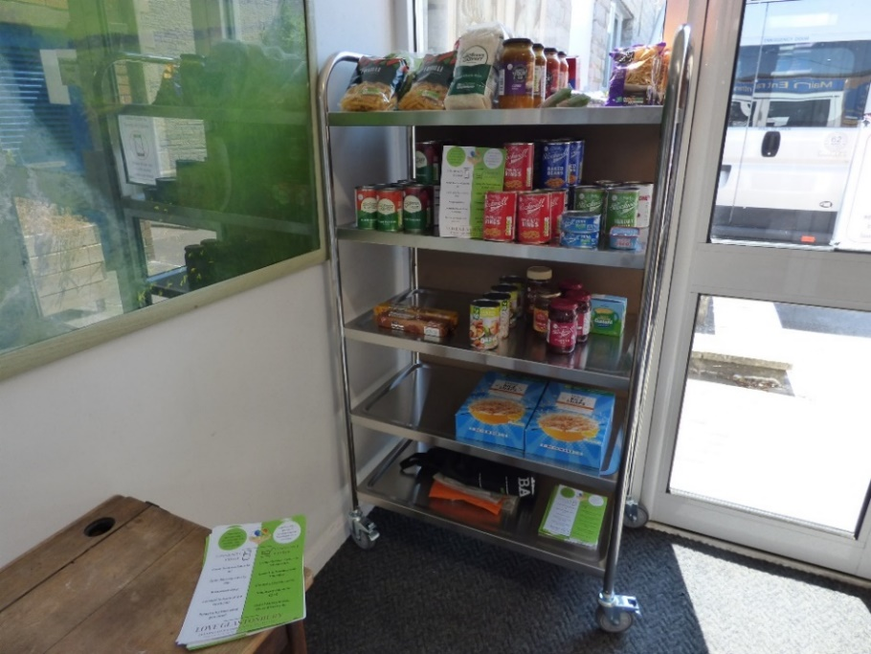
The pantry is situated by the front door.
Please help yourself…

